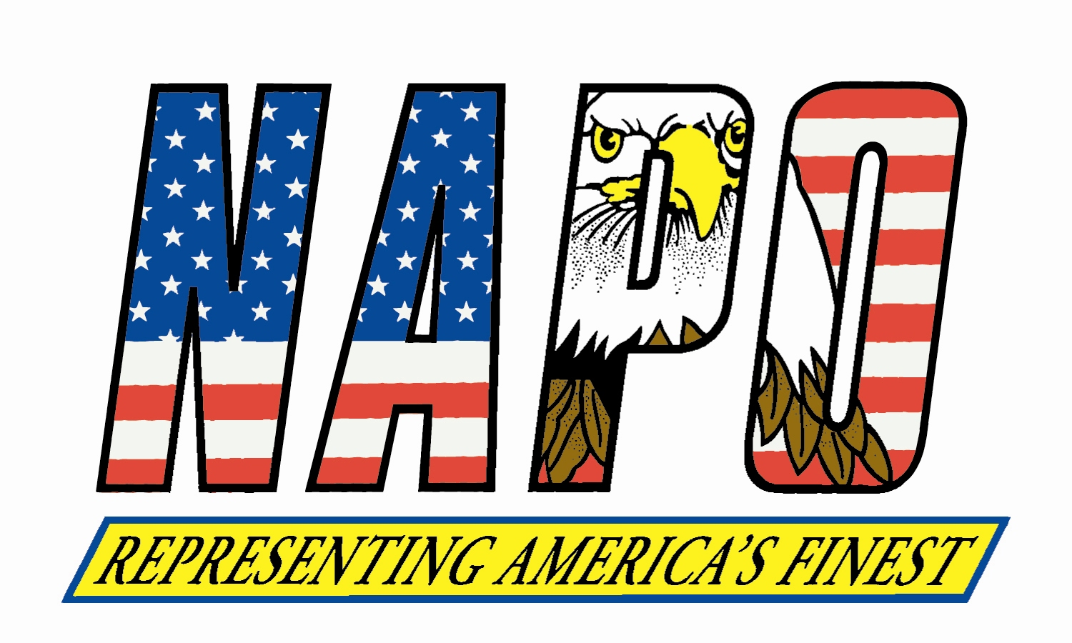January 14, 2014
Executive Officers

Thomas J. Nee
President
Boston Police
Patrolmen’s Association

MICHAEL McHALE
Executive Vice President
Florida Police Benevolent
Association

CHRIS COLLINS
Recording Secretary
Las Vegas Police
Protective Association

Sean M. Smoot
Treasurer
Police Benevolent & Protective
Association of Illinois

KEITH DUNN
Sergeant-at-Arms
New Jersey State Policemen’s
Benevolent Association

JOHN A. FLYNN
Executive Secretary
Patrolmen’s Benevolent
Association of New York City

William J. Johnson
Executive Director
NATIONAL ASSOCIATION OF POLICE ORGANIZATIONS, INC.
Representing America’s Finest
317 South Patrick Street. ~ Alexandria, Virginia ~ 22314-3501

(703) 549-0775 ~ (800) 322-NAPO ~ Fax: (703) 684-0515

www.napo.org ~ Email: info@napo.org

Executive Officers

Thomas J. Nee
President
Boston Police
Patrolmen’s Association

Michael MCHALE
Executive Vice President
Florida Police Benevolent
Association

CHRIS COLLINS
Recording Secretary
Las Vegas Police
Protective Association

Sean M. Smoot
Treasurer
Police Benevolent & Protective
Association of Illinois

KEITH DUNN
Sergeant-at-Arms
New Jersey State Policemen’s
Benevolent Association

JOHN A. FLYNN
Executive Secretary
Patrolmen’s Benevolent
Association of New York City

national headquarters

William J. Johnson
Executive Director
NATIONAL ASSOCIATION OF POLICE ORGANIZATIONS, INC.
Representing America’s Finest
317 South Patrick Street. ~ Alexandria, Virginia ~ 22314-3501

(703) 549-0775 ~ (800) 322-NAPO ~ Fax: (703) 684-0515

www.napo.org ~ Email: info@napo.org

The Honorable Barbara Mikulski
Chairwoman
Senate Appropriations Committee
503 Hart Senate Office Building
Washington, D.C. 20510

Dear Chairwoman Mikulski:

On behalf of the National Association of Police Organizations (NAPO), I am writing to express our appreciation for allocating funding for important justice grant programs, including the Community Oriented Policing Services (COPS) Program and the Byrne Justice Assistance Grant Program, in the Fiscal Year 2014 appropriations bill. These programs are vital as they provide necessary funding to assist state and local law enforcement efforts to keep communities safe. However, I am concerned that a component of the COPS Program, the Comprehensive School Safety Initiative, has been transferred to the National Institute of Justice. Moreover, the current language does not include funding for School Resource Officers (SROs).

NAPO is a coalition of police unions and associations from across the United States that represents more than 1,000 police units and associations, 241,000 sworn law enforcement officers, and more than 100,000 citizens who share a common dedication to fair and effective crime control and law enforcement.

Since its inception, the COPS Office has been extremely effective in carrying out its mission. We respectfully request you transfer the Comprehensive School Safety Initiative back to the COPS Office and include SROs in the grant description. We are also hopeful you will consider funding the program at the level described in the Fiscal Year 2014 President’s Budget Request - $150 million.

We very much appreciate your consideration. If NAPO can provide any additional information, please feel free to contact me at: (703) 549-0775.

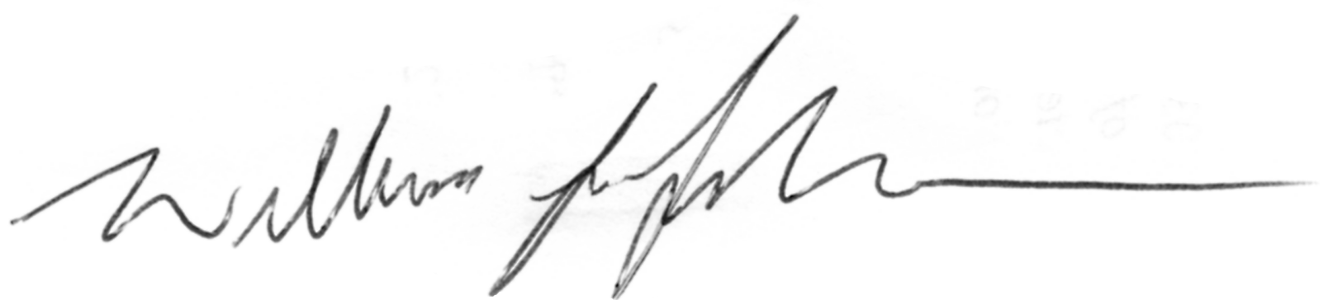Sincerely,

William J. Johnson
Executive Director

